# PRACTICAL 8:

Objective**:** Write a program to create a frame using AWT. Implement mouseClicked(), mouseEntered() and mouseExited() events such that:

* Size of the frame should be tripled when mouse enters it
* Frame should reduce to its original size when mouse is clicked in it
* Close the frame when mouse exits it Code

Code:

import java.awt.*; import java.awt.event.*;

public class PracEight extends Frame implements MouseListener { final int length = 100;

final int breadth = 100; PracEight() { super("AWT Frame");

this.setSize(this.length, this.breadth); this.setLayout(null); this.setVisible(true); this.addMouseListener(this); this.addWindowListener(new WindowAdapter() {

public void windowClosing(WindowEvent e) { dispose();

}

});

}

public static void main(String[] args) { new PracEight();

}

@Override

public void mouseClicked(MouseEvent e) { this.setSize(this.length, this.breadth);

}

@Override

public void mousePressed(MouseEvent e) {

}

@Override

public void mouseReleased(MouseEvent e) {

}

@Override

public void mouseEntered(MouseEvent e) { this.setSize(3 * this.length, 3 * this.breadth);

}

@Override

public void mouseExited(MouseEvent e) { this.dispose();

}

}

**OUTPUT:**

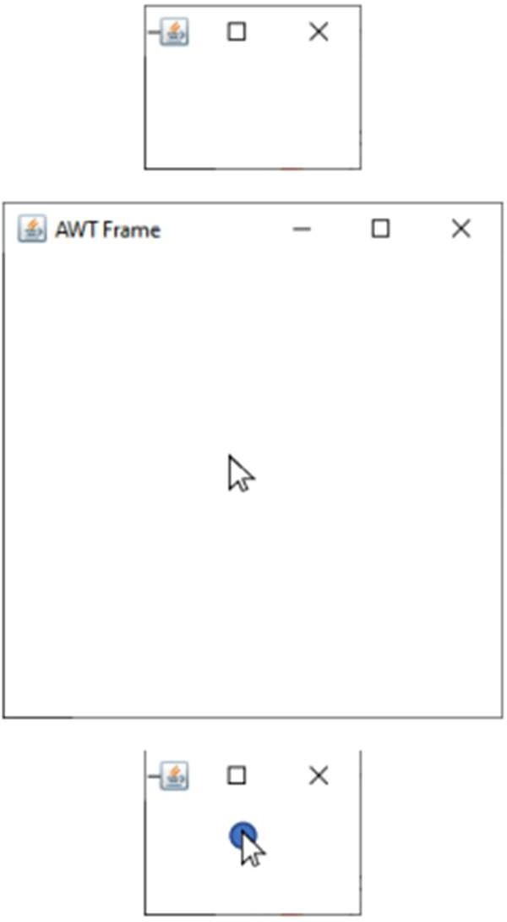

# PRACTICAL 9:

Objective: Using AWT, write a program to display a string in frame window with pink color as background.

Code:

import java.util.*; import java.awt.*; import java.awt.event.*;

public class PracNine extends Frame{ Label l;

PracNine(){

super("AWT Pink");

i = new Label("This is a Label");

i.setBounds(25,60,250,30); i.setAlignment(Label.CENTER); this.add(i); this.setSize(300,100); this.setLayout(new FlowLayout()); this.setBackground(Color.pink); this.setVisible(true);

this.addWindowListener(new WindowAdapter(){ public void windowClosing(WindowEvent e) { dispose();

}

});

}

public static void main(String[] args){ new PracNine();

}

}

**OUTPUT:**

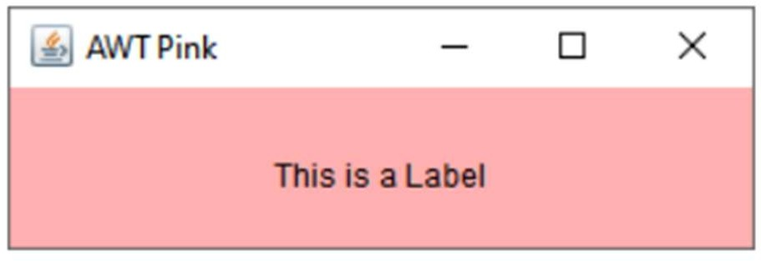

# PRACTICAL 11:

Objective: Using AWT, write a program using appropriate adapter class to display the message (“Typed character is: X”) in the frame window when user types any key.

Code:

import java.awt.*; import java.awt.event.*;

class KbdAdapter extends KeyAdapter { Label l;

KbdAdapter(Label l) { this.l = l;

}

@Override

public void keyTyped(KeyEvent e) {

l.setText("Typed character is: " + e.getKeyChar());

}

}

public class Main extends Frame { Label l;

Main() {

super("AWT Keyboard"); l = new Label("");

l.setBounds(25, 50, 250, 30); l.setAlignment(Label.CENTER); this.addKeyListener(new KbdAdapter(l)); this.add(l);

this.setSize(300, 110); this.setLayout(null); this.setVisible(true); this.addWindowListener(new WindowAdapter() {

public void windowClosing(WindowEvent e) { dispose();

}

});

}

public static void main(String[] args) { new Main();

}

}

**OUTPUT:**

